**Section13 Facade Design Pattern**

**Lesson01 what is Façade Design Pattern**

**Notes:-**

**1-facad design pattern: exposing multiple components through single interface**

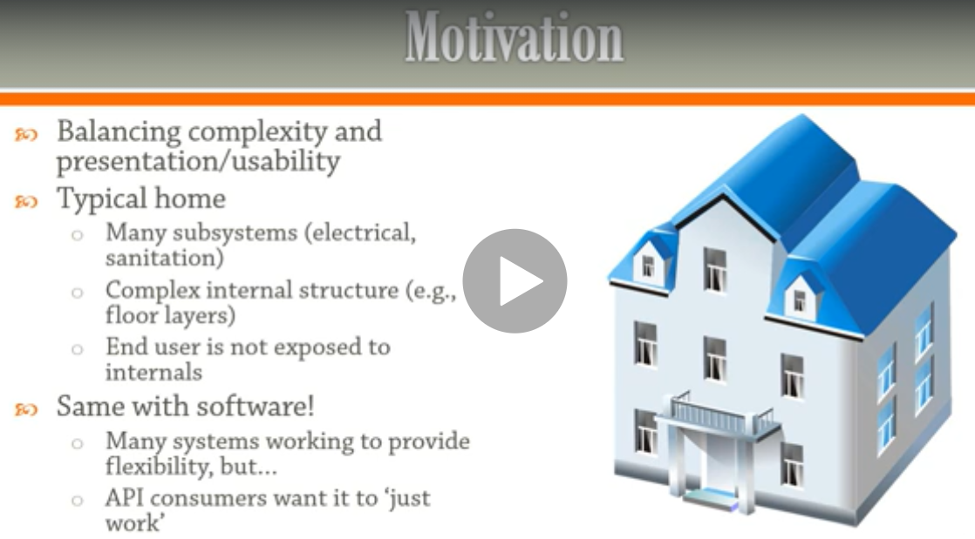

**3-as another sample of using façade design pattern when to use any method from any DLL it just call method inside interface**

**4-Façade provide simple, easy to understand user interface over large of sophisticated body of code**

**5-Facade pattern hides the complexities of the system and provides an interface to the client using which the client can access the system. This type of design pattern comes under structural pattern as this pattern adds an interface to existing system to hide its complexities.**

**Example:-**

**In the below example we see that we implement façade design pattern by make interface that implement circle , rectangle , square to shape interface and using gateway class to inject the shapes as properities not arguments as private and using public method to using it directly as below**

